



Microsoft Dynamics NAV 2013 R2 Implementation

Functional requirements document

Prepared for:   
**Ensight Finance**

Project:   
**Ensight Finance NAV 2013 Implementation**

Prepared by:   
**LLP**

Table OF Contents

1. INTRODUCTION 3

1.1. Purpose 4

2. FINANCIAL MANAGEMENT 5

2.1. Chart of accounts 5

2.2. Accounting periods 6

2.3. Periodic activities 6

2.4. Currencies 9

2.5. Bugets 9

2.6. Bank Accounts 10

2.7. Cash management 10

2.8. Dimensions 10

2.9. General Journals 12

3. FIXED ASSETS 15

3.1. Fixed assets numbering 15

3.2. Fixed asset posting groups 15

3.3. Fixed Asset classification 15

3.4. FA Depreciation books 16

3.5. Depreciation methods 16

3.6. Fixed assets depreciation 16

3.7. Fixed assets purchasing 16

3.8. Fixed Assets output transactions 16

3.9. Fixed Assets reevaluation 17

3.1. Fixed Assets reclasification 17

4. PAYABLES 18

4.1. Vendors 18

4.2. Purchase flows 18

4.3. Payments process 19

4.4. Compensations between customers and vendors 19

4.5. Payment terms 19

4.6. Vendors balance reconciliation 19

4.7. Prepayments (advances) 19

4.8. Item charges 20

4.9. Vendor discounts 20

5. SALES 21

5.1. Customers 21

5.2. Sales flows 21

5.3. Sales invoices formats 22

5.4. Customer payment terms 22

5.5. Customers balance reconciliation 22

5.6. Prepayments 22

5.1. Customer discounts 23

6. INVENTORY 24

6.1. Inventory posting groups 24

6.2. Costing Method 24

6.3. Item transactions 24

6.4. Item locations 25

# INTRODUCTION

This document is the result of the analysis phase of the project. Its purpose is to document all the functional requirements of the solution to be implemented. Once completed, this document will help to identify potential problems and requirements in functionality, the proposed design and also help create a final project plan.

This Functional Requirement Document (FRD) is one of the key project documents.

Though it shall be used as a basis for agreeing a project budget for the remainder of the project this FRD is by nature a living document and as such must be updated accordingly. This means that if a new requirement arises during the execution of the project or changes to already captured requirements are made, a new version of the document has to be issued and agreed between the parties. Update of the FRD may also mean that a change to the project budget is approved which shall be done by raising a Change request (CR).

The analysis phase has consisted of a workshop based around a standard set of analysis questionnaires to establish the Ensight Finance business model to be controlled using Microsoft Dynamics NAV 2013 R2 RTC.

From the work performed, this document was compiled to provide the following system documentation:

1. A functional requirements document listing selected use cases (this document FRD);

2. Fit Gap Analysis document;

The list of requirements in scope will form the basis to which Ensight Finance NAV 2013 implementation will be designed. The document identifies and documents Ensight Finance requirements.

## Purpose

The purpose of the FRD is to communicate business needs in common terms to all project and technical team members to ensure the end product meets the business objectives.

It is the first phase of the ***Systems Development Life Cycle***.

The Project will be executed as follows:

In the beginning of implementation of Ensight Finance we will manage the following processes:

* Accounting and financial management
* Purchasing and payables operations
* Sales and receivables operations
* Inventory management and stock control
* Providing structured data to the Reporting and Consolidation system for Management Reporting

Standard functionality of Microsoft Dynamics NAV 2013 RTC does not cover the requirements in full and for this reason a number of additional developments have been identified. The full list of additional developments (non-standard functionalities) included in the scope is clearly specified in this document and detailed further in the FIT/GAP document.

In the second phase of the project will be planned the following tasks and activities:

* Purchase order approval workflow
* Purchase invoice approval workflow
* Sales order approval workflow
* Sales invoice approval workflow
* Supplementary reports, functionalities, interfaces.

# FINANCIAL MANAGEMENT

## Chart of accounts

Ensight Finance Company uses a chart of accounts with a detailed structure, each bank account/ partner account having an analytical account.

NAV 2013 R2 chart of accounts will be set up in accordance with the chart of accounts published in OMF 3055/2009, which has a structure of classes / subclasses / analytical accordance with the laws in force.

The Chart of Accounts and analysis structures support multiple hierarchies for reporting statutory reports and management reports. The chart of accounts is built as an array of accounts codes (e.g. types of expenses) and transactional analysis codes (dimensions) (e.g. Location). The code is alphanumeric and can be up to 20 characters long.

The accounts will be:

* Balance Sheet Accounts
* Accounts results

Each type determines how transactions are processed and posted in these accounts and also provide grouping for reporting.

Balance sheet accounts are detailed in the class 1 to 5.

Income statements accounts are defined in 6 and 7 classes.

Principles of solution offered are:

* The chart of accounts is used to statutory reporting;
* Debtors and creditors are defined on specific common analytical accounts (e.g. 40101 – Furnizori Interni, 40102 – Furnizori UE, 41101 – Clienti interni, 41102 – Clienti UE, etc).

Balance sheet accounts will have a maximum length of 20 characters (numbers). Each account code will have a search name that will contain the description of the account.

In the attached file we have proposed a Chart of Account structure according with the Romanian law requirements. This structure could be used as an example and why not as a base for the new chart of accounts that need to be exported from Ciel and reorganized.



In the current financial application used by Ensight (Ciel), all the customers and vendors have a dedicated analytical GL Account. The behavior is not required in NAV 2013, and we can have only one GL Account necessary for posting on different Customer/Vendor Groups.

**Resolution**: NAV provides a flexible Chart of Accounts with Totaling & Posting accounts structured   
as Balance or Income statement type. Ensight Finance will provide a Local Chart of Account structure. In this structure the Totaling functionality will be used for summarizing the account’s figures.

LLP will send an import template with instructions on how to populate the required fields.

## Accounting periods

The fiscal year is represented by the calendar year, having 12 accounting periods, representing every fiscal period.   
These accounting periods will be setup accordingly in NAV 2013.

## Periodic activities

#### Close income statement

At the end of each month it is necessary to run the procedure that will debit all the revenues account movements and credit all the expenses movements using a closing account. The income statement transactions will be registered on a specific Closing date (e.g. C31.09.2014) grouped by various Dimensions values.

**Resolution**: The functionality is supported by the NAV Romanian localization package.

#### VAT Closing

At the end of each month, the user will check the balances of the deductible and collected VAT, and a manual GL transaction will be posted through General Journals.

**Resolution:** The feature is a NAV standard functionality.

#### Exchange rate adjustments

Ensight Finance will receive and send invoices in different currencies (mainly in EUR or USD).

At the end of every month it`s legally required to update all the open balances in local currency for vendors, customers or bank accounts that have transactions in foreign currencies.

The Adjust Exchange Rates batch job can be used to adjust customer, vendor and bank account entries to reflect a more updated balance if the exchange rate has changed since the entries were posted.

For customer and vendor accounts, the procedure adjusts the selected currency by using the exchange rate that is valid on the posting date that is specified in the batch procedure. The batch job calculates the differences for the individual currency balances and posts the amounts to the general ledger account that is specified in the Unrealized Gains Acc. (765) field or the Unrealized Losses Acc. (665). Balancing entries are automatically posted to the receivables/payables (401/411 GL Accounts) account in the general ledger.

For bank accounts, the procedure adjusts the currency by using the exchange rate that is valid on the posting date specified in the batch job. The batch job calculates the differences for each bank account that has a currency code and posts the amounts to the general ledger account that is specified in the Realized Gains Account (765) or the Realized Losses Account (665) in the Currency table. Balancing entries are automatically posted to the general ledger bank accounts that are specified in the bank account posting groups (5121, 5214).

**Resolution:** The feature is a NAV standard functionality.

#### 394/390/300 Statements

Ensight Finance will need to generate and send the following VAT Statement reports:

1. 394 Statement (Domestic Declaration) – should be generated and sent until 25th of the following fiscal month

**Resolution:** The feature is a NAV standard functionality. A TXT or XML file compatible with the A or J applications will be exported from NAV and validated by the indicated software.

1. 390 Statement (VIES) – should be generated and sent until 25th of the following fiscal month

**Resolution:** The feature is a NAV standard functionality.

1. 300 Statement (VAT Statement) – should be generated and sent until 25th of the following fiscal month.

**Resolution:** The feature is a NAV standard functionality.

#### VAT Journals

The following VAT Journals formats will be delivered to Ensight. These reports are developed with the latest modifications required by Romanian fiscal laws.



Purchase/Sale VAT could have the following percentages:

* 24% (majority)
* 9% (for bakery and books)
* 5% (for certain types of constructions)
* 0% (free of vat)

**Resolution:** The VAT Journals formats will be delivered with the format presented above.

#### Balance sheet report

Ensight Finance has to send the Balance sheet report according with the local statutory laws.

**Resolution**: This report will be constructed in the Account Schedule module, according with the valid format published on ANAF website (F10 format).



Also, Ensight Finance has sent a local Balance sheet format (BALANCE SHEET_EN_FIN sheet in the Raport Lunar 2014.xlsx file above), that will need to be constructed in the MS Dynamics NAV 2013

**Resolution**: This report can be setup in the Account Schedule module (if the all data are available in NAV Database), similar to the legal Balance Sheet. This task can be accomplished by Ensight personnel, and it is outside the scope of the project.

NAV offers an Excel type environment of selectable columns & rows with mathematical functions to enable Accounting staff to construct their own management and analysis reports. Output offers standard NAV drill-down capability as well as single button push output to Excel if required.

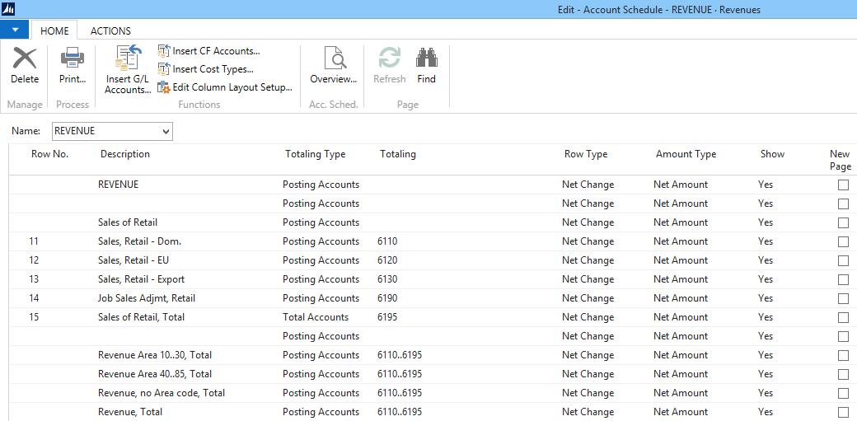

Figure 1 - Account Schedule report setup

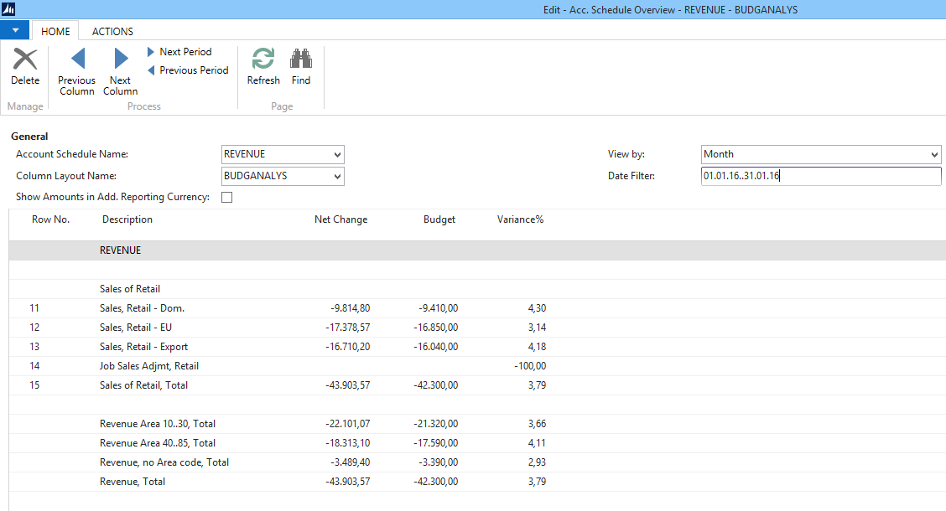

Figure 2 - Account Schedule report overview

#### Profit and Loss report

Ensight Finance has to send the Profit and Loss sheet report according with the local statutory laws.

**Resolution**: This report will be constructed in the Account Schedule module, according with the valid format published on ANAF website.

Also, Ensight Finance has sent a local format of P&L format (P&L FN 2014sheet in the file Raport Lunar 2014.xlsx), that will need to be designed from MS Dynamics NAV 2013.

**Resolution**: This report can be setup in the Account Schedule module (if the data are saved in NAV Database), similar to the legal Balance Sheet. This task can be accomplished by Ensight personnel, and it is outside the scope of the project.

#### Cash flow forecast statement

Ensight Finance requires an actual cash flow report that calculates all the amounts based on treasury accounts movements (sheet *Cash Flow Statement,* in the *Raport Lunar 2014.xlsx* file).

**Resolution**: The data necessary to obtain the report could be extracted from NAV (from different tables). The design of this report is not included in the scope of the project.

## Currencies

The **local currency** used to generate all the statutory reports is **RON**.

As companies operate in increasingly more countries/regions, it becomes more important that they be able to review or report financials in more than one currency. Dynamics NAV 2013 supports use of multiple currencies. Within the program, your general ledger is set up using your local currency (LCY), and another currency is set up as an **additional currency**, with a current exchange rate assigned.

By designating a second reporting currency as an **additional currency** the program will automatically record amounts in both LCY (RON) and this additional reporting currency on each G/L entry and on other entries (customer, vendor ledgers).

Is has been established that EUR will be the additional reporting currency for Ensight Finance.

**Resolution:** The standard Microsoft Dynamics NAV functionality fulfills this requirement.

## Budgets

An internal budget has to be maintained in NAV. The budget structure will be exported to Excel, where it will be populated and then imported back into NAV.

The budget is set up around October for the following year. The time unit of the budget is the fiscal month, and the budgeted values will be set on dimensions values as well.

Also, the budget structure can be copied from one period to another (e.g. 2013 budget as a reference for 2014 budget).

**Resolution**: NAV 2013 standard budgets functionality will be used, for the budgets in local currency (RON). Also, Ensight Finance requires that the budgeted values should be presented in EUR using an average currency exchange rate.

The budget in EUR request is not supported by NAV, and it can be obtained through a customization. An estimation will be sent to Ensight.

## Bank Accounts

Microsoft Dynamics NAV bank management allows to monitor deposits, payments, bank balances and to reconcile bank account statements.

In NAV the bank accounts of the Company is registered in Bank Cards. In the bank card the Bank balance can be seen in different currencies – the original currency of the bank account (e.g. EUR) and the local currency (e.g. RON) as well.

Ensight Finance collaborates with 2 banks:

* UNICREDIT (with different accounts in EUR and RON).
* ING (with different accounts in EUR and RON).

The bank accounts list and GL Accounts necessary to be set up will be populated in the Excel template that will be sent to be completed.

For automatic connection with the bank, an Electronic Banking interface will be implemented which can manage:

* Automatic registering of bank statements through importing file from bank
* Automatic closing of paid invoices by matching the payment to them.

**Resolution**: The online interface between NAV and the specified banks online application will be implemented in the scope of the project.

## Cash management

Petty cash functionality will be handled with the standard bank account card.

Each petty cash account (CASA RON, CASA EUR) will be represented by a dedicated bank account in bank account table.

**Resolution**: No gap has been identified. We will use the standard cash management functionality.

## Dimensions

In NAV, Dimensions functionality provides possibility to analyze deeper than Chart of Accounts level. The dimensions can be set up on the same way as the Chart of Accounts with totaling feature. All the dimensions can be predefined or attached to all the transactions.

An example can be found in the print screen below, where we can see an indented structure of AREA dimension values.

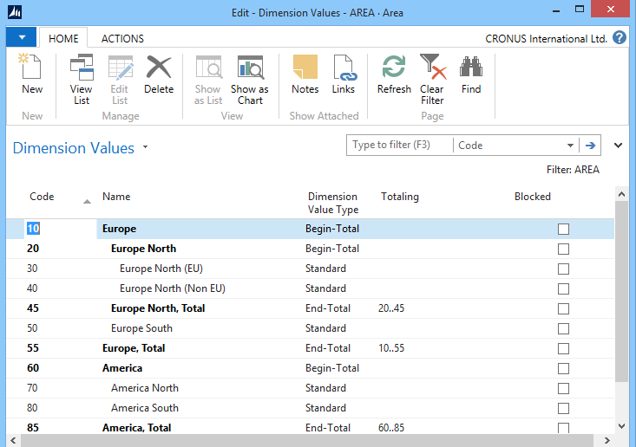

Figure 3 – Hierachy of dimension values

The following dimensions have been identified, and will be created in NAV 2013 R2:

|  |  |
| --- | --- |
| **Code** | **Name** |
| **COST CENTER** | Centre Cost |
| **PROIECT** | Proiecte |
| **ANGAJAT** | Angajati |
| **TIP MISIUNE** | Tip misiune |
| **DED/NEDED** | Cheltuieli Deductibile/Nedeductibile |
| **IMPOZABIL** | Impozabil |

The following values have been discused with Ensight users:

* COST CENTER: IT, MARKETING, HR, ADMINISTRATIV, FINANCE, COMUN_IT, COMUN_MK, COMUN_HR, COMUN_ADM
* PROIECT – the values will be provided from time@work (Project ID).
* ANGAJAT – the values will be provided from time@work (Employee ID).
* TIP MISIUNE – the values can be provided from time@work task list.
* DED/NEDED: DEDUCTIBIL, NEDEDUCTIBIL

Another approach will be to create 2 different analytical GL accounts for every expense account, and to forget about creating the DED/NEDED dimension.

* IMPOZABIL: IMPOZABIL, NEIMPOZABIL

The same approach could be used for the revenues GL Account (2 different analytical GL Accounts for every Revenue account).

## General Journals

In NAV the different transactions can be registered through journals as well. This means the classical accounting procedure with defining the debit and credit accounts directly.

The journals can be grouped by function (Journal Templates). Within each group unlimited journals can be defined. (Journal Batches) Either in Template or in Batch level a different set of rules can be defined for journals e.g. numbering, balancing account, VAT registering etc.

In NAV there is a possibility to use Analytical accounts in journals.

The following Journal templates will be created for Ensight Finance implementation:

|  |  |  |
| --- | --- | --- |
| **Name** | **Description** | **Type** |
| CASA | Operatiuni efectuate prin casa | General |
| DECONTURI | Deconturi cu angajati | General |
| EXTRASE | Jurnal Extrase | General |
| GENERAL | jurnal General | General |
| INCASARI | jurnal incasari | Încasari |
| INCHIDERE | Jurnal de inchidere TVA/ cheltuieli si venituri | General |
| M_FIXE | Mijloace fixe | Imobilizari |
| OP DIV | Operatiuni diverse | General |
| PLATI | Jurnal Plati | Plati |
| RECURRING | Recurring General Journal | General |
| SALARII | Note de salarii | General |
| SALES | Sales journal | Vânzari |
| SI | Solduri initiale | General |

Every template will have multiple batches with the user name in order to permit concurrent access to the same journal templates.

Ensight Finance charges services to the customers according with the number of G/L transactions registered. In order to count the number of transactions, we need to create a new field “Mark transactions”, that will be manually checked.   
LLP will develop a report that will count all the G/L transaction lines posted on a certain period.

**Resolution**: This is a gap and will be developed. LLP will send an estimation.

#### Recurring Journals

In NAV there is a possibility to predefine journals. Typical use of it is Payroll registering, accruals or rents registering.   
Recurring method and frequency or reversing routine can be defined as required.

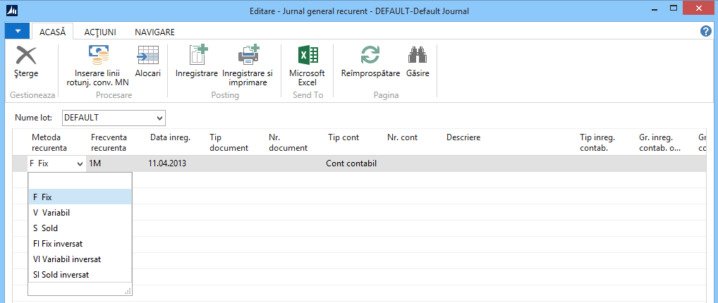

Figure 4 – Recurency method in recurring journals

**Resolution**: The NAV 2013 standard recurring journals will be used to post and keep track of the recurring GL transactions.

#### Payment Journals

NAV can offer the upcoming payments with Suggest Vendor payments functionality in Payment Journal. The payments which should be or shouldn’t be processed can be selected from the offered ones. NAV can be forced to use Vendor priority in offering.

NAV offers the bank account of the vendor if it was registered on vendor card. It can be selected manually or modified if necessary as well.

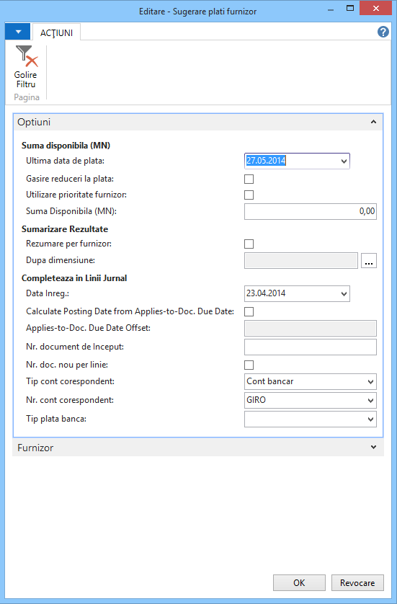

Figure 5 – Suggest vendor payments

# FIXED ASSETS

## Fixed assets numbering

The Fixed assets list will be composed of typical Fixed Assets, and small inventory items (303).

Each group will have a different internal numbering range. The fixed assets could start with MF001 number, and the small inventory items could have OB0001 number series.

**Resolution**: Ensight Finance will send a fixed assets list that will be completed according with a fixed structure provided by LLP.

## Fixed asset posting groups

Each fixed asset has to have a posting group which will dictate the acquisition, depreciation, accumulated depreciation, disposal accounts.

The fixed assets posting groups could be structured in the way presented in the table below:

|  |  |  |  |
| --- | --- | --- | --- |
| **FA Posting Group** | **Acquisition Cost Account** | **Depreciation Account** | **Depreciation Cost Account** |
| CONSTRUCT | 212001 | 281201 | 681101 |
| ECHIPAMENT | 213101 | 281311 | 681101 |
| INSTALATII | 213201 | 281320 | 681101 |
| TRANSPORT | 213301 | 281311 | 681101 |
| MOBILIER | 214001 | 281301 | 681101 |
| OB_INV | 303001 | 303001 | 603005 |

**Resolution:** The table presented below will be revised by Ensight personnel according with their own needs and specific GL Accounts presented in the Chart of Accounts.

## Fixed Asset classification

In order to classify all the fixed assets, NAV will provide a FA catalog according with the legal requirements. The classification structure can be found below:



This table will be imported in FA Subclass section

**Resolution:** No gaps found in this section.

## FA Depreciation books

NAV provides multiple “Depreciation Books” to specify multiple depreciation environments (straight line, declining balance etc) for specific asset treatment.

Ensight Finance will use a CONTABIL Depreciation book, which will generate GL transactions (acquisitions, depreciations, sales, and disposals).

Another FISCAL Depreciation book will be set up. This depreciation book will not be integrated with the financial module.

**Resolution:** No gaps found in this section.

## Depreciation methods

Straight line depreciation method will be used. On some case the accelerated depreciation method will be setup (on certain IT equipment’s).

**Resolution:** No gaps found in this section.

## Fixed assets depreciation

The depreciation procedure will be calculated monthly based on the acquisition costs, accumulated depreciations, and the remaining days left.

If the fixed assets that are included in the depreciation procedure are integrated with the general ledger (defined in the depreciation book), the program transfers the entries to the fixed assets general ledger journal. Otherwise, the batch job transfers the entries to the fixed asset journal. You can then post the journal or adjust the entries before posting, if necessary.

**Resolution:** No gaps found in this section.

## Fixed assets purchasing

The fixed assets can be purchased directly from internal suppliers or from online stores.

**Resolution:** No gaps found in this section.

## Fixed Assets output transactions

The fixed assets can be sold to specific customers, or disposed.

The G/L transactions generated will be according with the template presented below:

|  |  |  |  |
| --- | --- | --- | --- |
| Sale | 411 | = | % |
|  |  |  | 7583 |
|  |  |  | 4427 |
|  |  |  |  |
| Loss on sale | % | = | 212 |
|  | 2812 |  |  |
|  | 6583 |  |  |
| Profit on sale | 2812 | = | % |
|  |  |  | 212 |
|  |  |  | 7583 |

|  |  |  |  |
| --- | --- | --- | --- |
| Disposal | % | = | 212 |
|  | 2812 |  |  |
|  | 6583 |  |  |

**Resolution:** The standard Microsoft Dynamics NAV functionality fulfills this requirement.

## Fixed Assets reevaluation

According to the Romanian legislation, fixed assets reevaluation can be performed under certain conditions. The accounting transactions should be done according to that legislation.

**Resolution**: The fixed assets reevaluation can be implemented in Microsoft Dynamics NAV using the Index procedure.

## Fixed Assets reclasification

According to the Romanian legislation, fixed assets reclasification can be performed under certain conditions. The accounting transactions should be done according to that legislation.

**Resolution:** The standard Microsoft Dynamics NAV functionality fulfills this requirement.

# PAYABLES

## Vendors

Vendors can be classified according with the following criteria:

1. Based on suppliers region:

* Internal vendors (FZ_RO)
* UE Vendors (FZ_UE)
* NON UE Vendors (FZ_NONUE)

2. Based on unrealized VAT

* Vendors that will send invoices with unrealized VAT (some of internal Vendors)
* Vendor with deductible VAT.

**Resolution:** The standard Microsoft Dynamics NAV functionality fulfills this requirement.

## Purchase flows

Ensight Finance purchase standard procedure will start with 3 quotes from 3 different vendors regarding the same service/item/fixed asset. This quote will be automatically archived in the system for future references. The winning quote will be transform into a purchase order.   
When the item is received, from the purchase order we can generate a receipt (NIR) and register the purchase invoice.

There is no need to register the received merchandise/goods on “408 - Furnizori - facturi nesosite” GL Account.

**Resolution:** The standard Microsoft Dynamics NAV functionality fulfills this requirement.

There two types of purchase orders:

* Services
* Goods (small inventory items: mobile phones, fixed telephones; consumables: toner, office stationery; spare parts: for automobiles, and different IT equipment).

#### Purchase invoice

One purchase invoice may refer to one or more receipts (will be handled with standard Dynamics NAV 2013 functionality).

No internal invoice needs to be printed from Dynamics NAV.

**Resolution:** The standard Microsoft Dynamics NAV functionality fulfills this requirement.

## Payments process

In order to decide which vendor invoices should be paid, Ensight Finance will extract a list of due invoices that the partners will need to approve.

After the approval process is finished, the invoice payments are inputted and post from the payment journals.

During the last step, the matching between the invoice and the payment could be done (online application). Also, the application can be done later, after the payment has been posted.

**Resolution:** The standard Microsoft Dynamics NAV functionality fulfills this requirement.

## Compensations between customers and vendors

When the same partner is both customer and supplier, compensations will be made between the purchase invoice and sales invoice.

**Resolution:** The standard Microsoft Dynamics NAV functionality fulfills this requirement.

## Payment terms

Payments terms can be set up on a vendor cards, and will be suggested on purchase documents, but can be modified according with the agreement with the vendors.

In order to have a correct and efficient aging reports based on due dates, all the vendors will need to have specific Payment terms code setup on it.

**Resolution:** The standard Microsoft Dynamics NAV functionality fulfills this requirement.

## Vendors balance reconciliation

The following vendor balance reconciliation format has been presented and will be used in order to reconcile balances with different vendors.



**Resolution:** The standard Microsoft Dynamics NAV functionality fulfills this requirement.

## Prepayments (advances)

Some vendors can ask that certain payments needs to be made in advance, in order to deliver the purchase order.

The G/L transactions posted are:

1. Advance payment

|  |  |  |
| --- | --- | --- |
| 409 | = | 5121 |

1. Receiving and registering the prepayment invoice

|  |  |  |
| --- | --- | --- |
| % | = | 401 |
| 409 |  |  |
| 4426 |  |  |

1. Prepayment compensation

|  |  |  |
| --- | --- | --- |
| 401 | = | 409 |

1. Purchase invoice posting

|  |  |  |
| --- | --- | --- |
| % | = | 401 |
| 3xx/6xx |  |  |
| 4426 |  |  |
| -409 |  |  |
| -4426 |  |  |

**Resolution:** The standard Microsoft Dynamics NAV functionality fulfills this requirement.

## Item charges

Ensight Finance will receive different purchase invoices containing items. If the transport or other types of charges are contained on the same invoices, these charges will be applied proportional with the quantity and the unit cost of every item.

If these additional costs will be invoiced on a different purchase document, then they will be recognized as expenses.

**Resolution:** The standard Microsoft Dynamics NAV functionality fulfills this requirement.

## Vendor discounts

Vendor will calculate and show discounts on invoices.

The following G/L transaction needs to be posted in NAV:

|  |  |  |
| --- | --- | --- |
| % | = | 401 |
| 6024 |  |  |
| 4426 |  |  |
| 609 |  |  |

**Resolution:** The standard Microsoft Dynamics NAV functionality fulfills this requirement.

# SALES

## Customers

Ensight Finance uses time@work, a time/services recording core system in which all the customers are managed.

The customers will be created in NAV 2013 as well.

The customers grouping in NAV could be done according with the region origin:

* Domestic Customers (**CL_RO**)
* UE Customers (**CL_UE**)
* NON-UE Customers (**CL NON-UE**)

## Sales flows

Ensight Finance is offering to the customers the following services types:

* **Recurrent services (based on subscription):** bookkeeping and payroll services
* **Ad-hoc services (on request):** fiscal consultancy, accounting consultancy, audit, etc.
* **Project services**: based on daily tasks fees (kept in time@work), based on different seniority levels.
* **Renting office space invoices**

These services are registered in time@work by the employees who work of different projects. The timesheets are inputted weekly.

The invoicing is done at the end of every month, in time@work. In the actual financial system (Ciel) the sales invoices are registered manually.

It has been requested that an automatic interface has to be developed between time@work and NAV.

This will consist in exporting the sales invoices data from time@work according with a requested file format and importing the file in NAV 2013. After NAV will receive the necessary data, the batch posting procedure would generate the G/L transactions.

Time@work needs to mark all the sales invoices export to NAV, in order not to re-export them again on a future passing.



**Resolution:** The import interface in NAV needs to be developed as is not a standard functionality.

A development and testing estimation will be sent to Ensight.

## Sales invoices formats

The sales invoices are printed from time@work for the invoiced services.

Occasional sales could be directly generated and printed from NAV (e.g. selling of fixed assets or small inventory objects).

The invoice amounts are printed in the currency specified in the contract (RON for domestic customers, EUR or USD for the foreign customers).

**Resolution**: A fiscal invoice layout will be delivered by Ensight Finance, in order to be developed in NAV 2013.

## Customer payment terms

Payments terms can be set up on a customer cards, and will be suggested on sales invoices, but can be modified.

The payment terms will be used to calculate the due date of the invoice.

**Resolution:** For all the invoices that will be imported from time@work, the due date will be imported too. Thus, there is no need to maintain payment terms on customer cards.

## Customers balance reconciliation

The following customer balance reconciliation format has been presented and will be used in order to reconcile balances with different customers.



**Resolution:** The standard Microsoft Dynamics NAV functionality fulfills this requirement.

## Prepayments

In some special cases Ensight Finance will require advances (30 – 40% from the final value) from customers in order to start the projects.

The final invoice sent to the customer will credit the prepayment (419) and debit the entire amount on the final receivables account (411).

The G/L transactions posted are:

1. Advance receiving

|  |  |  |
| --- | --- | --- |
| 5121 | = | 419 |

1. Prepayment invoice posting:

|  |  |  |
| --- | --- | --- |
| 411 | = | % |
|  |  | 419 |
|  |  | 4427 |

1. Prepayment compensation

|  |  |  |
| --- | --- | --- |
| 419 | = | 411 |

1. Sales invoice posting

|  |  |  |
| --- | --- | --- |
| 411 | = | % |
|  |  | 7xx |
|  |  | 4427 |
|  |  | -419 |
|  |  | -4427 |

**Resolution:** The standard Microsoft Dynamics NAV functionality fulfills this requirement.

## Customer discounts

Customer discounts will not be detailed on specific G/L Account. The unit price of sold services/items will contain the discounts.

**Resolution:** The standard Microsoft Dynamics NAV functionality fulfills this requirement.

# INVENTORY

## Inventory posting groups

It has been determined that Ensight Finance will use the inventory module on a pilot company. This company will be used to create additional new companies, in which the inventory transactions of Ensight Finance actual customers might be kept.

The inventory posting groups that will be setup are the following:

|  |  |
| --- | --- |
| **Code** | **Description** |
| CONS_IT | Consumabile IT |
| P_SCHIMB | Piese Schimb |

Additional posting groups can be set up when there will be necessary.

## Costing Method

The costing method determines if an actual or a budgeted value is capitalized and used in the cost calculation. Together with the posting date and sequence, the costing method also influences how the cost flow is recorded. The following methods are supported in Microsoft Dynamics NAV 2013:

|  |  |
| --- | --- |
| **Costing method** | **Description** |
| **FIFO** | An item’s unit cost is the actual value of any receipt of the item, selected by the FIFO rule. In inventory valuation, it is assumed that the first items placed in inventory are sold first. |
| **LIFO** | An item’s unit cost is the actual value of any receipt of the item, selected by the LIFO rule. In inventory valuation, it is assumed that the last items placed in inventory are sold first. |
| **Average** | An item’s unit cost is the exact cost at which the particular unit was received. |
| **Specific** | An item’s unit cost is calculated as the average unit cost at each point in time after a purchase. For inventory valuation, it is assumes that all inventories are sold simultaneously. |
| **Standard** | An item’s unit cost is preset based on estimated. When the actual cost is realized later, the standard cost must be adjusted to the actual cost through variance values. |

FIFO Costing method will be setup on all item cards by default in Ensight Finance.

**Resolution:** The standard Microsoft Dynamics NAV functionality fulfills this requirement.

## Item transactions

In Ensight Finance will purchase different IT consumables and spare parts (auto and IT) and then consumed (recognizing the expenses)

No item selling is necessary to be setup.

The internal consumption note will have the following format.

- 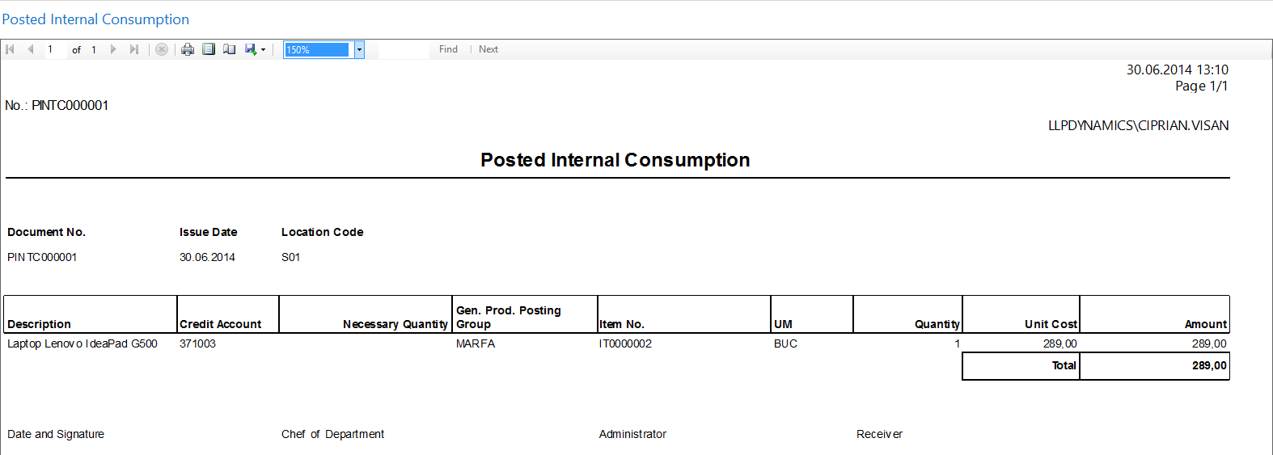

Figure 6 – Internal consumption layout

**Resolution:** The standard Microsoft Dynamics NAV functionality fulfills this requirement.

## Item locations

Ensight Finance will use only one location (SEDIU) in order to detail the items purchasing and consuming. No item internal transfers are necessary to be setup.

**Resolution:** The standard Microsoft Dynamics NAV functionality fulfills this requirement.